|  |
| --- |
|  |
| |  | | --- | | New World Development Company Limited | | Lung Tin Tsuen Phase 3 | | Building Energy Simulation Report | |  | | Issue3 | 30 November 2018 | |

|  |  |  |
| --- | --- | --- |
| This report takes into account the particular  instructions and requirements of our client.  It is not intended for and should not be relied  upon by any third party and no responsibility  is undertaken to any third party.  Job number -- |  | ArupLogo2010_k_OvaWord1000mm_CompoundTransparent_100kGreyscale.wmf |
|  |
| **Ove Arup & Partners Hong Kong Ltd**  Level 5 Festival Walk  80 Tat Chee Avenue  Kowloon Tong  Kowloon  Hong Kong  www.arup.com |

|  |  |  |  |  |  |  |  |  |  |  |  |
| --- | --- | --- | --- | --- | --- | --- | --- | --- | --- | --- | --- |
| Document Verification | | | | | | ArupLogo2010_k_OvaWord1000mm_CompoundTransparent_100kGreyscale.wmf | | | | | |
|  | | | | | |  | | | | | |
|  | | |  | | | | |  | | | |
| Job title | | | Lung Tin Tsuen Phase 3 | | | | | Job number | | | |
| -- | | | |
|  | | |  | | | | |  | | | |
| Document title | | | Building Energy Simulation Report | | | | | File reference | | | |
|  | | | |
|  | | |  | | | | | | | | |
| Document ref | | |  | | | | | | | | |
|  | |  |  |  | | | | | | | |
| Revision | | Date | Filename | 180608\_EU1\_Energy simulation report\_v1.docx | | | | | | | |
|  | |  |  |  | | | | | | | | |
| Issue | | 8 Jun 2018 | Description | Issue | | | | | | | |
|  | Prepared by | | Checked by | | Approved by | | | |
| Name | Kelvin Chow | | Ricky Li | | Tony Lam | | | |
| Signature |  | |  | |  | | | |
|  | |  |  |  | | | | | | | | |
| Issue2 | | 18 Sep 2018 | Filename | EU1\_Energy simulation report\_v2.docx | | | | | | | |
| Description | Issue2 | | | | | | | |
|  | Prepared by | | Checked by | | Approved by | | | |
| Name | Katsuya Obara | | Ricky Li | | Tony Lam | | | |
| Signature |  | |  | |  | | | |
|  | |  |  |  | | | | | | | | |
| Issue3 | | 30 Nov 2018 | Filename | EU1\_Energy simulation report\_v3.docx | | | | | | | |
| Description | Issue3 | | | | | | | |
|  | Prepared by | | Checked by | | Approved by | | | |
| Name | Katsuya Obara | | Ricky Li | | Tony Lam | | | |
| Signature |  | |  | |  | | | |
|  | |  |  |  | | | | | | | | |
|  | |  | Filename |  | | | | | | | |
| Description |  | | | | | | | |
|  | Prepared by | | Checked by | | Approved by | | | |
| Name |  | |  | |  | | | |
| Signature |  | |  | |  | | | |
|  | | | | | | | | | | |
| Press **Control+Shift+D** to insert or remove DV sheet | | | | Issue Document Verification with Document | | | |  | ✓ |  |
|  | | | | | | | | | | |

Contents

Page

[Executive Summary 1](#_Toc531335565)

[1 Introduction 5](#_Toc531335566)

[2 Methodology 7](#_Toc531335567)

[2.1 Energy/CO2 Emission Performance Assessment Framework 7](#_Toc531335568)

[2.2 Simulation Approach 9](#_Toc531335569)

[2.3 Simulation Software 9](#_Toc531335570)

[2.4 Simulation Procedures 11](#_Toc531335571)

[2.5 Reference Codes or Guidelines 11](#_Toc531335572)

[2.6 Exceptional Calculation Method 12](#_Toc531335573)

[3 Project Information 13](#_Toc531335574)

[3.1 General Description 13](#_Toc531335575)

[3.2 General Weather Information 14](#_Toc531335576)

[3.3 Space Information 15](#_Toc531335577)

[4 Energy Conservation Measures 16](#_Toc531335578)

[4.1 Reducing building façade glazing area 16](#_Toc531335579)

[4.2 Common area efficient lighting strategies 16](#_Toc531335580)

[4.3 Energy saving AC units in residential flats 16](#_Toc531335581)

[4.4 Efficient lift power consumption 16](#_Toc531335582)

[5 Modelling Parameters 17](#_Toc531335583)

[5.1 Input Parameters Summary Table 18](#_Toc531335584)

[5.2 Exceptional Calculation Method 25](#_Toc531335585)

[6 Results and discussion 27](#_Toc531335586)

[6.1 EU 1 Reduction of CO2 Emissions 27](#_Toc531335587)

[6.2 Simulation Results 27](#_Toc531335588)

[6.3 EU 2 Peak Electricity Demand Reduction 33](#_Toc531335589)

[7 Conclusion 36](#_Toc531335590)

References

Tables

Figures

Drawings

Pictures

Photographs

Attachments

Appendices

Modelling Parameters

The modelling parameters for the Baseline Model were made reference to the settings for the Reference Building model for energy study as stipulated in BEAM Plus v1.2 Manual. Regarding the Proposed model, detailed design specification is listed in the summary table of section 5.1.

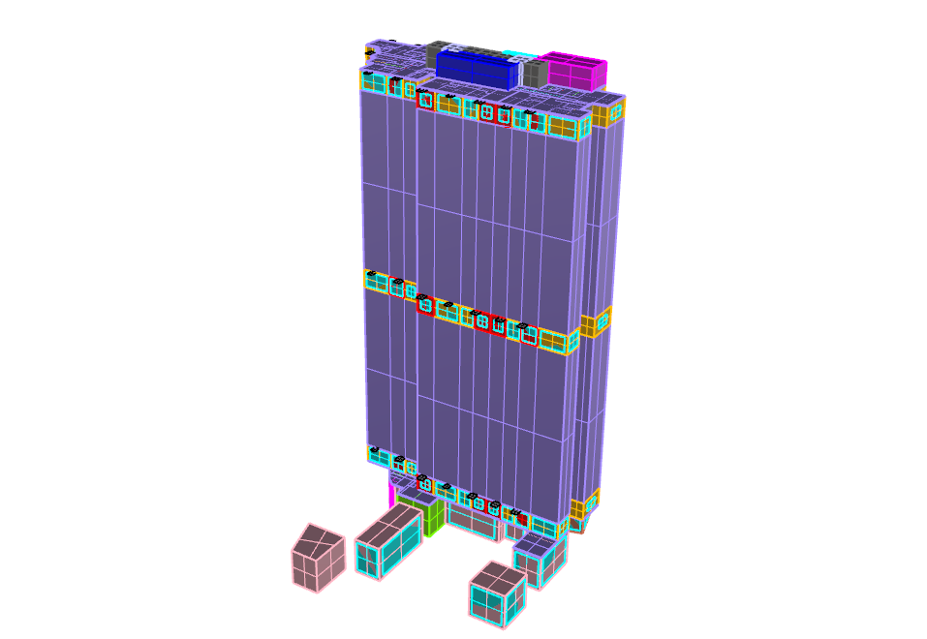

**N**

Figure 3D model for energy modelling

The table below presents the comparison of proposed design versus baseline design energy model inputs. These include the descriptions for:

* Exterior wall, roof, floor, and slab assemblies including framing type, assembly U-values, and roof reflectivity.
* Fenestration types, assembly U-values (including the impact of the frame on the assembly), SHGCs, and visual light transmittances, overall window-to-gross wall ratio and fixed shading devices.
* Interior lighting power densities, process lighting power.
* Equipment, escalators and other process loads.
* HVAC system information including types and efficiencies.
* Schedule information
  1. Input Parameters Summary Table

The Model parameters and information of baseline case and design case can be summarized and listed in the table as below.

**Building Envelope**

|  |  |  |
| --- | --- | --- |
| Model Input Parameter | Proposed Design Input | Reference Building/ Baseline Design Input\* |
| Roof  Design Case  *(Please refer to Building Material Specifications for details)*  Baseline Case  *(With reference to BEAM Plus default characteristics for other types building)* | Layer 1 – Concrete Tiles fixed with cement slurry  Thickness (m): 0.035  Thermal conductivity (W/mK): 1.1  Solar absorptivity: 0.7  Layer 2 – Cement / Sand Bedding  Thickness (m): 0.04  Thermal conductivity (W/mK): 0.72  Layer 3 – Extruded Polystyrene Form  Thickness (m): 0.04  Thermal conductivity (W/mK): 0.034  Layer 4 – Cement / Sand Screed  Thickness (m): 0.02  Thermal conductivity (W/mK): 0.72  **U-value for roof: 0.66 W/m2.K** | Layer 1 – Concrete Tiles  Thickness (m): 0.005  Thermal conductivity (W/mK): 1.1  Density (kg/m3): 2100  Specific heat (J/kgK): 920  Solar absorptivity: 0.65  Layer 2 – Asphalt  Thickness (m): 0.02  Thermal conductivity (W/mK): 1.15  Density (kg/m3): 2350  Specific heat (J/kgK): 1200  Layer 3 – Cement/Sand Screed  Thickness (m): 0.05  Thermal conductivity (W/mK): 0.72  Density (kg/m3): 1860  Specific heat (J/kgK): 840  Layer 4 – Expanded Polystyrene  Thickness (m): 0.05  Thermal conductivity (W/mK): 0.034  Density (kg/m3): 25  Specific heat (J/kgK): 1380  Layer 5 – Heavy Concrete  Thickness (m): 0.15  Thermal conductivity (W/mK): 2.16  Density (kg/m3): 2400  Specific heat (J/kgK): 840  Layer 6 – Gypsum Plaster  Thickness (m): 0.01  Thermal conductivity (W/mK): 0.38  Density (kg/m3): 1120  Specific heat (J/kgK): 840  Solar absorptivity: 0.65  **U-value for roof: 0.55 W/m2.K** |
| External Wall Construction  Design Case  *(Please refer to Building Material Specifications for details)*  Baseline Case  *(With reference to BEAM Plus default characteristics for other types building)* | (Type 1)  Layer 1 – Mosaic Tiles  Thickness (m): 0.005  Thermal conductivity (W/mK): 1.5  Solar absorptivity: 0.84  Layer 2 – Cement Screeding  Thickness (m): 0.03  Thermal conductivity (W/mK): 0.72  Layer 3 – Concrete Wall  Thickness (m): 0.15  Thermal conductivity (W/mK): 2.16  Layer 4 – Gypsum Plaster  Thickness (m): 0.015  Thermal conductivity (W/mK): 0.38  **U-value for Type 1 wall: 3.15W/m2.K**  (Type 2)  Layer 1 – Glass  Thickness (m): 0.01  Thermal conductivity (W/mK): 1.05  Solar absorptivity: 0.84  Layer 2 – Cement Screeding  Thickness (m): 0.01  Thermal conductivity (W/mK): 0.72  Layer 3 – Concrete Wall  Thickness (m): 0.1  Thermal conductivity (W/mK): 2.16  Layer 3 – Gypsum Plaster  Thickness (m): 0.015  Thermal conductivity (W/mK): 0.38  **U-value for Type 2 wall: 2.31W/m2.K**  (Type 3)  Layer 1 – Glass  Thickness (m): 0.01  Thermal conductivity (W/mK): 1.05  Solar absorptivity: 0.84  Layer 2 – Cement Screeding  Thickness (m): 0.01  Thermal conductivity (W/mK): 0.72  Layer 3 – Concrete Wall  Thickness (m): 0.4  Thermal conductivity (W/mK): 2.16  Layer 3 – Gypsum Plaster  Thickness (m): 0.015  Thermal conductivity (W/mK): 0.38  **U-value for Type 3 wall: 1.75W/m2.K**  (Type 4)  Layer 1 – Mosaic Tiles  Thickness (m): 0.005  Thermal conductivity (W/mK): 1.5  Solar absorptivity: 0.84  Layer 2 – Cement Screeding  Thickness (m): 0.03  Thermal conductivity (W/mK): 0.72  Layer 3 – Concrete Wall  Thickness (m): 0.25  Thermal conductivity (W/mK): 2.16  Layer 4 – Gypsum Plaster  Thickness (m): 0.015  Thermal conductivity (W/mK): 0.38  **U-value for Type 4 wall: 2.75W/m2.K**  (Type 5)  Layer 1 – Glass  Thickness (m): 0.01  Thermal conductivity (W/mK): 1.05  Solar absorptivity: 0.84  Layer 2 – Cement Screeding  Thickness (m): 0.185  Thermal conductivity (W/mK): 160  **U-value for Type 5 wall: 5.74W/m2.K**  **Area weighted Average U-value for wall: 2.99W/m2.K** | Layer 1 – Mosaic Tiles  Thickness (m): 0.005  Thermal conductivity (W/mK): 1.5  Density (kg/m3): 2500  Specific heat (J/kgK): 840  Solar absorptivity: 0.58  Layer 2 – Cement/Sand Plastering  Thickness (m): 0.01  Thermal conductivity (W/mK): 0.72  Density (kg/m3): 1860  Specific heat (J/kgK): 840  Layer 3 – Heavy Concrete  Thickness (m): 0.1  Thermal conductivity (W/mK): 2.13  Density (kg/m3): 2400  Specific heat (J/kgK): 840  Layer 4 – Gypsum Plastering  Thickness (m): 0.01  Thermal conductivity (W/mK): 0.38  Density (kg/m3): 1120  Specific heat (J/kgK): 840  Solar absorptivity: 0.65  **U-value for wall: 3.84W/m2.K** |
| Window-to-Gross Wall Ratio (WWR) | **WWR (Overall): 0.37**  *(Input as designed, with reference to Building Elevation Drawings)* | **WWR: 0.4**  *(With reference to BEAM Plus default characteristics for residential building)* |
| Fenestration Properties  Design Case  *(Please refer to Building Material Specifications for details)*  Baseline Case  *(With reference to BEAM Plus default characteristics for other types building)* | Tinted Glass  Thickness (m): 0.006 (crystal grey) + 0.012 (air gap) + 0.012 (low iron)  **U-value: 1.63W/m2.K**  **Shading Coefficient: 0.35** | Tinted Glass  Thickness (m): 0.006  Thermal conductivity (W/mK): 1.05  Density (kg/m3): 2500  Specific heat (J/kgK): 840  Solar absorptivity: 0.65  **U-value: 5.32W/m2.K**  **Shading Coefficient: 0.65** |
| Shading Devices (Overhang / Fin) | Yes | Yes |
| \*Remarks:  For details of the default characteristics for the building envelope of the baseline building model please refer to BEAM Plus New Building V1.2, Appendix 8.2 as shown below: | | |

**HVAC System Input**

|  |  |  |
| --- | --- | --- |
| Model Input Parameter | Proposed Design Input  (According to design drawings & calculations) | Reference Building/ Baseline Design Input \*  (According to CoP for Energy Efficiency of Air-conditioning Installation 2015) |
| System Type | Unitary air-conditioner, split type (Residential part)  VRF system (Ground Floor) | Unitary air-conditioner, split type |
| System COP | 3.51 (Unitary air-conditioner)  3.6 (VRF) | 2.6 |
| Mechanical Ventilation | 20ACH (Bathroom) | 20ACH (Bathroom) |

**Lighting System Input**

|  |  |  |
| --- | --- | --- |
| Location/ Space | Proposed Design Input (According to design drawings & calculations) | Reference Building/ Baseline Design Input\*  (According to CoP for Energy Efficiency of Lighting Installation 2015 and BEAM Plus NB V1.2) |
|  | (W/m2) | (W/m2) |
| Office | 17 | 17 |
| Bathroom | 13 | 13 |
| Staircases | 4.5 | 8 |
| Refuse Rooms | 9 | 9 |
| Lift Lobby | 4.1 | 12 |
| Corridor | 8 | 8 |
| Plant Room | 7.3 | 11 |
| Store Rooms | 9 | 9 |
| Dining Room | 15 | 15 |
| Master Bedroom | 13 | 13 |
| Car Park | 1.94 | 5 |
| Lighting Controls | None | None |
| \* Remarks: For details of the baseline system please refer to BEC 2015 and BEAM Plus New Building V1.2, Appendix 8.2.  LPD for Proposed Design is calculated based on lighting specification. Please refer to “14-Lighting Input/LPD calculation.pdf” | | |

**Shower Hot Water System Input**

|  |  |  |
| --- | --- | --- |
| Model Input Parameter | Proposed Design Input  (According to design drawings & calculations) | Reference Building/ Baseline Design Input \*  (According to BEAM Plus Manual Appendix 8.6) |
| Shower flow rate | 6.5L/min | 6.5L/min |
| Shower duration | 300s | |
| Ave. Water Inlet/ Outlet Temperature | 23oC/ 41oC | |
| Total water flow rate\* (m3/s) | 0.0106 | 0.0106 |

\*total shower hot water flow rate would reference to occupancy density for each tower

**Equipment Loads Input**

|  |  |  |
| --- | --- | --- |
| Small Power Equipment Density (W/m2) | Proposed Design Input | Baseline Design Input |
| Staircases | 0 | |
| Store Rooms | 0 | |
| Bathroom | 10 | |
| Lift Lobby | 0 | |
| Bedroom | 10 | |
| Corridor | 0 | |
| Dining Room | 10 | |
| Offices | 25 | |
| Plant Room | 0 | |
| Refuse Rooms | 0 | |

**Indoor Set Points**

|  |  |  |
| --- | --- | --- |
| Temperature & Humidity Design (\*) | Proposed Design Input | Baseline Design Input |
| Summer Time | For all conditioned areas: 22 oC | |
| Winter Time | For all conditioned areas: 18 oC | |
| \*Remarks:  The outdoor and indoor design conditions are based on Technical Schedule | | |

**Occupancy Density**

|  |  |  |
| --- | --- | --- |
| Number of People (\*) | Proposed Design Input | Baseline Design Input |
| Tower | 1172 | |
| \*Remarks:  The number of people in the simulation is based on GBP drawings | | |

| Occupancy Density (\*) | Proposed Design Input | Baseline Design Input |
| --- | --- | --- |
| Staircases | 0 | |
| Store Rooms | 0 | |
| Bathroom | 0 | |
| Lift Lobby | 0 | |
| Master Bedroom, Bedroom, Dining Room | 0.222 ppl/m2 | |
| Corridor | 0 | |
| Kitchen | 0 | |
| Offices | 0 | |
| Plant Room | 0 | |
| Refuse Rooms | 0 | |
| \*Remarks:  People density is based on number of people stated in the GBP drawings | | |

**Schedule Summary**

With reference with the EMSD’s Performance-Based Building Energy Codes (2007), the following occupancy, lighting and equipment schedule is used in the simulation. For other load schedule, detailed explanation will be given in the “Exceptional Calculation Method” section.

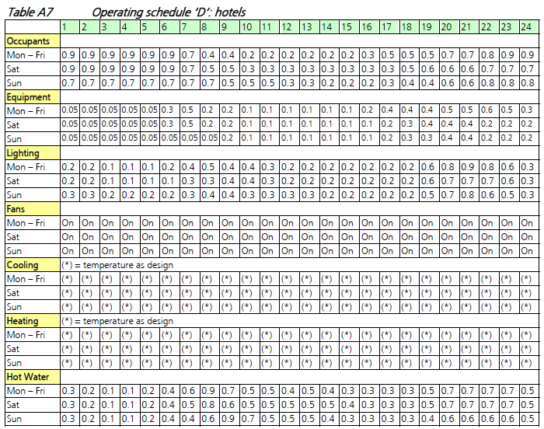

**Equivalent Carbon Dioxide CO2 Emissions Factor**

|  |  |
| --- | --- |
| Since there is a mix of fuel used in this building, the energy performance assessment will be based on the incurred carbon dioxide emission rather than the amount of energy used. The followings show the conversion factors to be used for this purpose: | |
| Electricity | 0.7kg CO2 per kWh electricity consumed  (From BEAM Plus NB v1.2 Appendix 8.3) |
| Town Gas | 3.141 kg CO2 per unit of town gas consumed  (1 unit of town gas = 48MJ)  (From BEAM Circular Letter 2013.115) |

**Compliance of Building Energy Code**

The Code of Practice for Energy Efficiency of Building Services Installation Prescriptive Option, which shall be strictly complied with as a pre-requisite for credits under the building energy performance assessment.

* 1. Exceptional Calculation Method

Exceptional Calculation approaches are adopted for the energy estimation of all kitchen appliances such as electric cooking, washing machine and refrigeration, Car Park, Plumbing & Drainage. The above mentioned items are independent of cooling load, heating load and the weather. The energy consumption of these items is non-dynamic and independent of other factors. In addition, they will become part of the total energy consumption and no savings are claimed of these items.

* + 1. Kitchen Appliances

It is assumed all flat types would have same provision of kitchen appliances including electric sn different flat types

|  |  |
| --- | --- |
|  | All Flat Types |
| Electric Cooking (kW) | 3.1 |
| Washing Machine (kW) | 2.2 |
| Refrigeration (kWh/yr) | 281 |

Based on the information above, the total equipment power of each tower is calculated and summarized below:

Table Total kitchen equipment power in each tower

|  |  |
| --- | --- |
|  | Power (kW) |
| Electric Cooking | 957.8 |
| Washing Machine | 688.6 |
| Refrigeration | 31.3 |

For refrigeration use, it is assumed the appliance will operate all the time throughout the entire year. For electric cooking and washing machine, many times they will not operate at full capacity because its diversity of use. In order to model them in the energy simulation, it is assumed that the equivalent operational hours is 0.5 hour of full capacity throughout the day for electric cooking and washing machine.

* + 1. Lift System

The lift system in the energy model calculation should include the residential lifts. The building services design would provide the total number of lifts in each tower, rated capacity and rated speed. Based on these information, the baseline motor power consumption can be reference to the BEC 2015 code of practice for lift and escalator installation Section 8.4.1.2.

The proposed lift system will contribute to energy saving by using a motor with less rated power. By calculating the total power consumption from each tower for baseline and proposed case, energy saving can be achieved.

|  |  |  | **BASELINE** | |  | **PROPOSED** | | |
| --- | --- | --- | --- | --- | --- | --- | --- | --- |
| **Rated Capacity (kg)** | **Rated Speed (m/s)** | **Power (kW)** | **Total (kW)** |  | **Power (kW)** | **Total (kW)** | |
| L1 | 900 | 2 | 19.4 | 77.6 |  | 16.5 | 66.0 |
| L2 | 900 | 2 | 19.4 |  | 16.5 |
| L3 | 900 | 2 | 19.4 |  | 16.5 |
| L4 | 900 | 2 | 19.4 |  | 16.5 |

* + 1. Car Park (Lighting & Fan)

Energy consumption for car park related to lighting and fan is calculated as exceptional calculation. energy consumption is calculated and added to energy consumption and peak demand calculation. Please refer to supporting document “20-ExceptionalCalc/ 01 CarPark\_ExcepCalc.pdf” for calculation detail.

* + 1. Plumbing & Drainage Pump

Energy consumption for all the pump related to P&D is calculated as exceptional calculation. According to the water usage estimation submitted in “WU1/Supporting Document/Water Use Estimation\_v2.pdf”,” WU6/Supporting Document/05-WU6-Flush Water Use Estimation\_v2.pdf”, energy consumption is calculated and added to energy consumption and peak demand calculation. Please refer to supporting document “10-Plumbing&Drainage/ EU1\_Energy\_Saving\_ Calculation\_Plumbing.pdf” for substantiation.

1. Results and discussion

The energy simulation results of Proposed Case and Baseline Case in terms of CO2 emission reduction & peak electricity demand reduction will be summarized in this section.

* 1. EU 1 Reduction of CO2 Emissions

Whole Building Energy Performance Assessment is performed to estimate the percentage of energy saving of a whole building load. The objective of EU 1 is to reduce the consumption of non-renewable energy resources and the consequent harmful emissions of Carbon Dioxide (CO2) to the atmosphere.

Since the project building belongs to residential building, the category for Residential Building Types (c) under EU 1 can be chosen as the credit assessment.

From the energy simulation and calculation result, 13.9%, 31.4% of the CO2 emissions reduction can be achieved for residential tower and car park respectively which contributes to 12 points and 15 points respectively out of 15 points in EU 1.

* 1. Simulation Results

The result of the whole building energy simulation showed that the Baseline Case had a total CO2 emission of 1,275.7 Tonnes of CO2, while the Design case building had 1,098.0 Tonnes of CO2 emission for residential tower. For car park, Baseline Case had a total CO2 emission of 51.5 Tonnes of CO2, while the Design case building had 35.3 Tonnes of CO2 emission for residential tower. This is an overall reduction of 13.9%, 31.4% in CO2 emissions for residential tower and car park respectively.

All the results below are already accounted for the exceptional calculation for electric cooking, refrigeration, plumbing & Drainage and car park.

Table Total CO2 emission breakdown of Baseline and Proposed Case for residential tower

|  |  |  |  |
| --- | --- | --- | --- |
| **Residential Tower** | | | |
| **Categories** | **Baseline Case** | **Proposed Case** | **% Saving** |
|  | **(kgCO2)/year** | **(kgCO2)/year** |  |
| Cooling | 377,905 | 240,502 | 36% |
| Lighting | 229,368 | 217,859 | 5% |
| Equipment | 103,152 | 103,152 | 0% |
| Lift | 193,034 | 164,079 | 15% |
| Electric Cooking | 73,414 | 73,414 | 0% |
| Washing Machine | 52,781 | 52,781 | 0% |
| Refrigeration | 191,932 | 191,932 | 0% |
| Mechanical Ventilation | 1,447 | 1,447 | 0% |
| Hot water | 34,285 | 34,285 | 0% |
| Plumbing & Drainage | 18,425 | 18,425 | 0% |
| **Total CO2 Emission (kgCO2)** | **1,275,741** | **1,097,950** | **13.9%** |
| **No. of credit attained** | **12** | | |

Table Average CO2 emission breakdown of Baseline Case for residential tower with rotation



Table Total CO2 emission breakdown of Baseline and Proposed Case for car park

|  |  |  |  |
| --- | --- | --- | --- |
| **Car Park** | | | |
| **Categories** | **Baseline Case** | **Proposed Case** | **% Saving** |
|  | **(kgCO2)/year** | **(kgCO2)/year** |  |
| Lighting | 26,538 | 10,297 | 61.2% |
| Mechanical Ventilation | 24,957 | 25,019 | -0.2% |
| **Total CO2 Emission (kgCO2)** | **51,496** | **35,316** | **31.4%** |
| **No. of credit attained** | **15** | | |

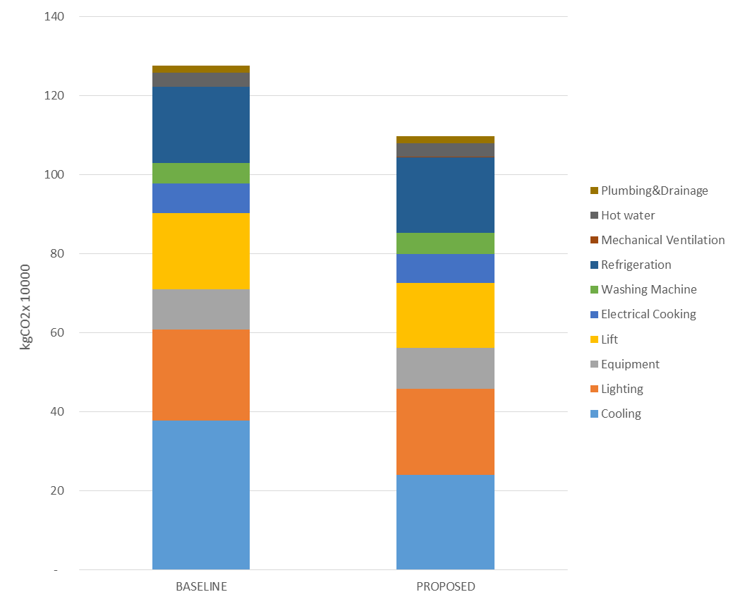

**13.9% Reduction**

Figure CO2 emission for Baseline and Proposed Case for residential tower

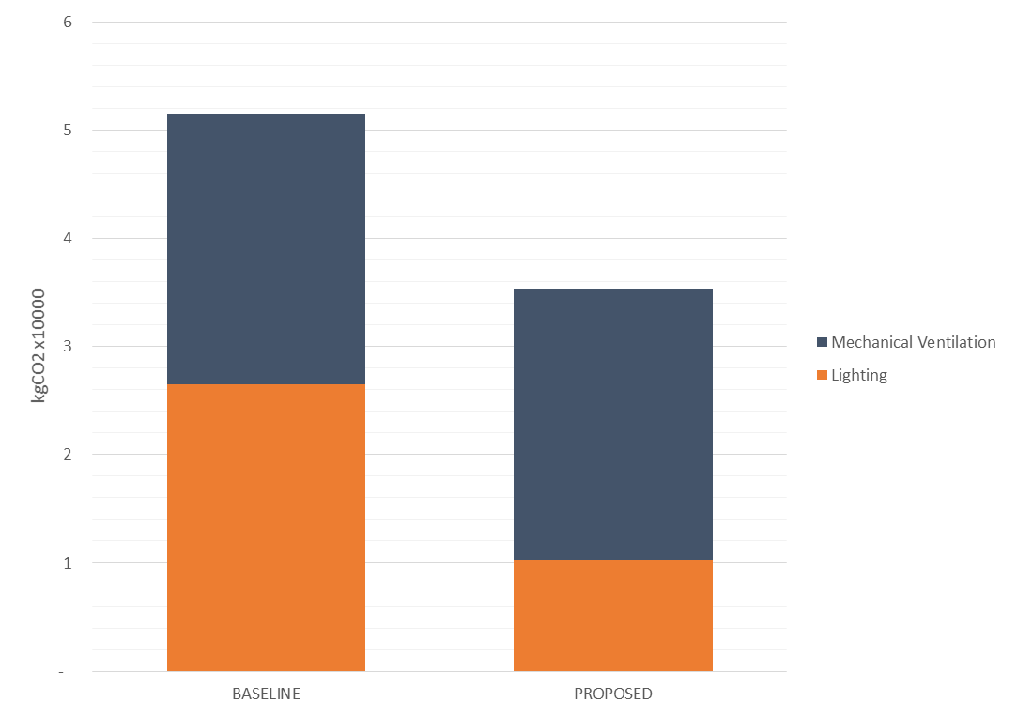

**31.4% Reduction**

Figure CO2 emission for Baseline and Proposed Case for car park

* + 1. Baseline Case and Proposed Design CO2 Breakdown

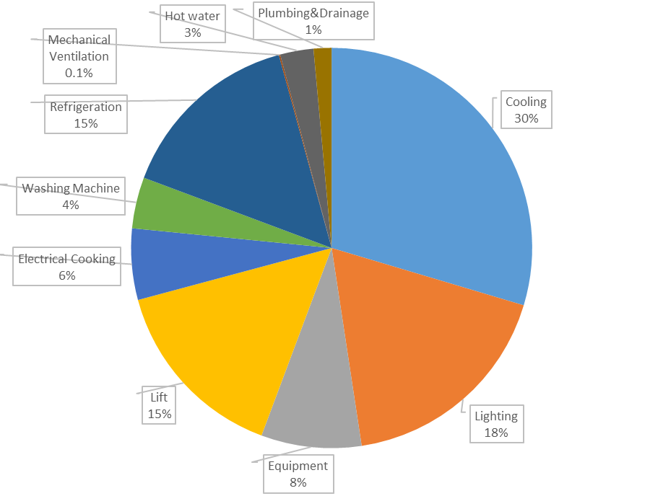

Figure Building CO2 breakdown under Baseline Case

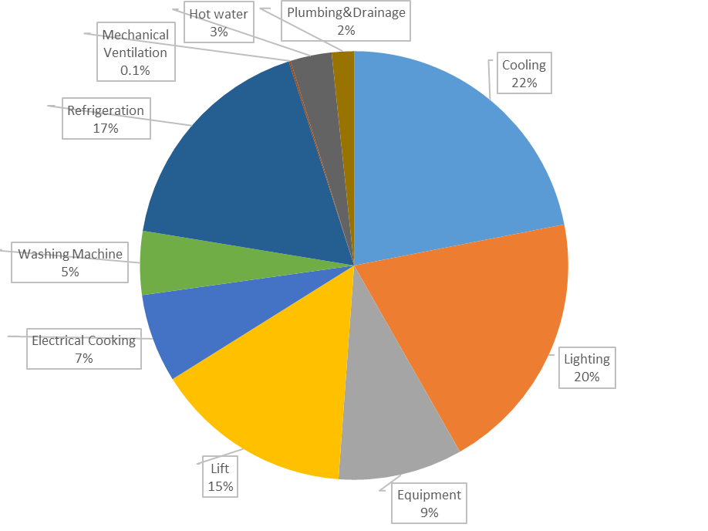

Figure Building CO2 breakdown under Proposed Case

Figure Categorized CO2 saving between Baseline and Proposed Case for residential tower

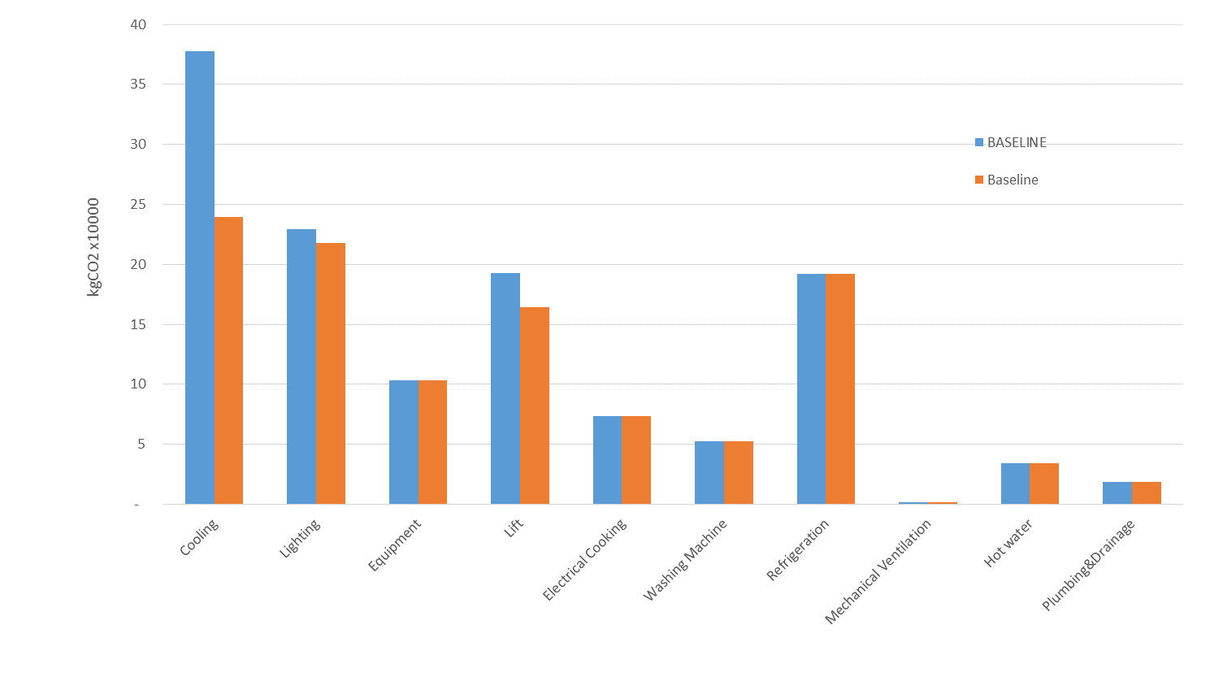

**36% Reduction**

**5% Reduction**

**15% Reduction**

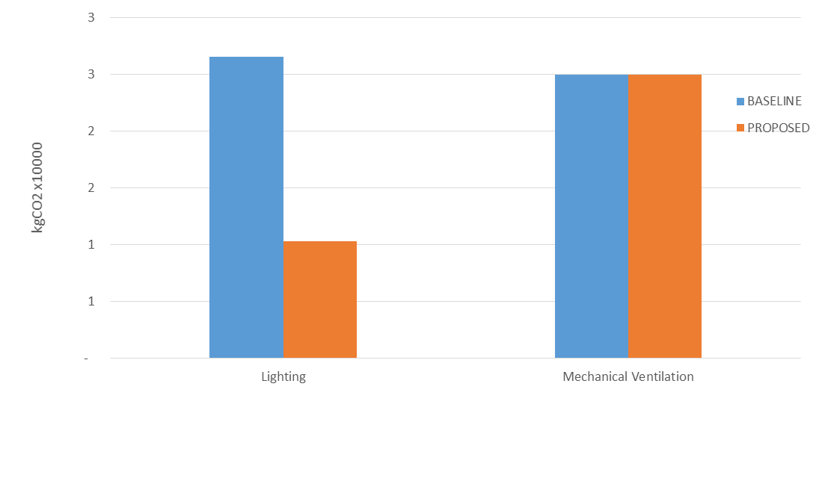

**61% Reduction**

Figure Categorized CO2 saving between Baseline and Proposed Case for car park

* 1. EU 2 Peak Electricity Demand Reduction

The objective of this credit is to encourage energy conservation and methods to reduce peak electricity demand.

According to the Credit Requirement, (c) “Residential Buildings” credit scale should be used for residential tower part, i.e., 1 to 3 credits for a reduction in the maximum electricity demand by 2%, 6% and 9% respectively. Also, (d) “Other Building Type” credit scale should be used for car park part, i.e., 1 to 3 credits for a reduction in the maximum electricity demand by 7%, 11% and 14% respectively.

The Peak Electricity Demand Reduction is summarized in the table as below.

Similar to section 6.2, the peak electricity demand reduction is mainly contributed by the high efficient cooling system. The AC system will operate only from Apr to Oct. A high COP AC unit can reduce the overall electricity usage, as well as peak electricity consumption.

Owing to the energy saving strategies, adopted in the Proposed Case, the peak electricity demand is reduced by 12.2% for residential tower, 31.4% for car park respectively. Therefore, 3 credits should be achieved for residential tower and car park according to BEAM Plus New Buildings v1.2.

Table Monthly Peak Electricity Demand of Baseline and Proposed Case for residential tower

|  |  |  |  |
| --- | --- | --- | --- |
| **Residential Tower** | | | |
| **Month** | **Baseline Case** | **Proposed Case** | **% Reduction** |
|  | **kW** | **kW** |  |
| January | 542.6 | 531.5 | 2.0% |
| February | 542.6 | 531.5 | 2.0% |
| March | 542.6 | 531.5 | 2.0% |
| April | 682.1 | 617.4 | 9.5% |
| May | 707.9 | 635.7 | 10.2% |
| June | 741.3 | 650.6 | 12.2% |
| July | 740.4 | 649.8 | 12.2% |
| August | 729.1 | 645.0 | 11.5% |
| September | 730.2 | 645.6 | 11.6% |
| October | 702.6 | 628.4 | 10.5% |
| November | 542.6 | 531.5 | 2.0% |
| December | 542.6 | 531.5 | 2.0% |
| **Peak Demand Reduction** | | | **12.2%** |
| **No. of credit attained** | **3** | | |

Table Monthly Peak Electricity Demand of Baseline and Proposed Case for car park

|  |  |  |  |
| --- | --- | --- | --- |
| **Residential Tower** | | | |
| **Month** | **Baseline Case** | **Proposed Case** | **% Reduction** |
|  | **kW** | **kW** |  |
| January | 8.4 | 5.8 | 31.4% |
| February | 8.4 | 5.8 | 31.4% |
| March | 8.4 | 5.8 | 31.4% |
| April | 8.4 | 5.8 | 31.4% |
| May | 8.4 | 5.8 | 31.4% |
| June | 8.4 | 5.8 | 31.4% |
| July | 8.4 | 5.8 | 31.4% |
| August | 8.4 | 5.8 | 31.4% |
| September | 8.4 | 5.8 | 31.4% |
| October | 8.4 | 5.8 | 31.4% |
| November | 8.4 | 5.8 | 31.4% |
| December | 8.4 | 5.8 | 31.4% |
| **Peak Demand Reduction** | | | **31.4%** |
| **No. of credit attained** | **3** | | |

Figure Categorized energy saving between Baseline and Proposed Case for residential tower

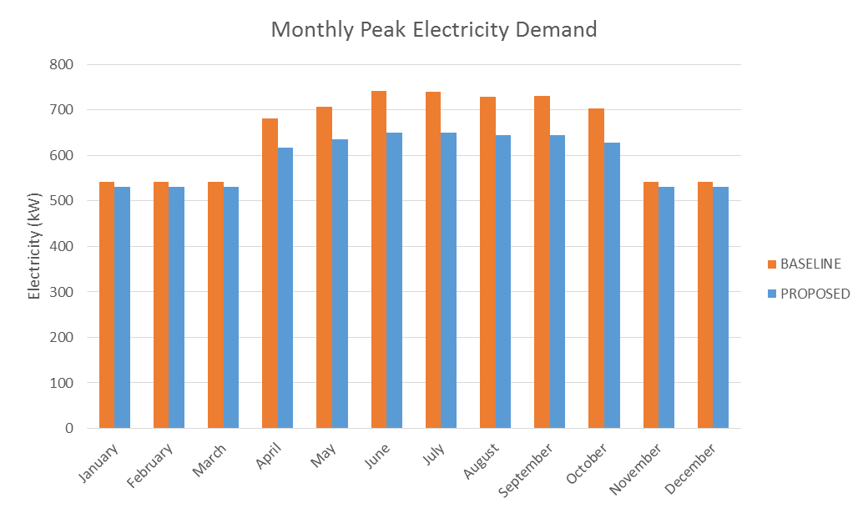

Peak month

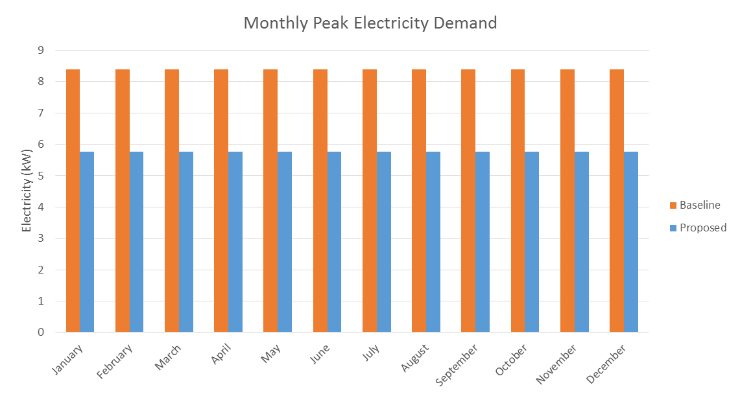

Peak month

Figure Categorized energy saving between Baseline and Proposed Case for car park

1. Conclusion

This energy analysis aims to compare the energy consumption and so the CO2 emission between the Baseline Case (mainly based on BEC2015) and the Proposed Design Case. The analysis result may not reflect the actual energy consumption during the building operation stage, because the energy consumption does depend on couples of assumptions, such as operating schedule, equipment power and the lighting and equipment decided by the users. The assumptions of this analysis comply with the requirements of Building Energy Codes 2015 as well as BEAM Plus Standard v1.2, which are believed that the analysis result is able to identify the Annual Energy Use and CO2 Emission Reduction between the cases based on accredited assumptions.

The Annual CO2 Emission Reduction of the proposed case are around 13.9% for the residential portion, 31.4% for the car park portion which are able to earn 12 points and 15 points from BEAM Plus v1.2 EU 1 respectively.

The peak electricity demand of the proposed case are reduced 12.2% for the residential tower , 31.4% for the car park portion, which are able to earn 3 points from BEAM Plus v1.2 EU2 for residential tower and car park respectively.

Table Point summary for residential tower

|  |  |  |
| --- | --- | --- |
| **BEAM Plus v1.2 Energy Use Credit** | **Maximum Points** | **Project Status** |
| EU Pre-requisite 1  Minimum Energy Performance | Pre-requisite | Compliance |
| EU 1  Reduction of CO2 Emissions | 15 | 12 |
| EU 2  Peak Electricity Demand Reduction | 3 | 3 |

Table Point summary for car park

|  |  |  |
| --- | --- | --- |
| **BEAM Plus v1.2 Energy Use Credit** | **Maximum Points** | **Project Status** |
| EU Pre-requisite 1  Minimum Energy Performance | Pre-requisite | Compliance |
| EU 1  Reduction of CO2 Emissions | 15 | 15 |
| EU 2  Peak Electricity Demand Reduction | 3 | 3 |